Computer Language Coding Concepts

Exit Command in a Diagram
The concept of exit command is already covered by the article Exit Command. This article only explains its expression in a diagram.

Exit Command is defined in a command definition. It will transfer control to the command, that immediately follows after it. The Exit Command command is passed the Command End as an argument:

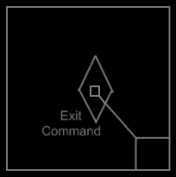

For information about the command end, see the article Normal Execution Order in a Diagram.

The normal execution order in the command definition is not yet pointing to the next step. It represents the normal execution order as it will be in a call to the command definition.

The Exit Command looks as follows inside a command call:

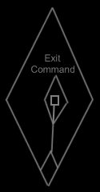

See also: Exit Command, Normal Execution Order in a Diagram

Author & Copyright: Jan-Joost van Zon Date: June 10, 2008 – June 11, 2008 Location: Oosterhout, The Netherlands Status: Finished

